主题：DP83848CVVXN-NOPB New and Original Ethernet IC Chips Electronics Circuits IN STOCK Good price&quality
Product Attributes
TYPE | DESCRIPTION
Category | Integrated Circuits (ICs)  Interface - Drivers, Receivers, Transceivers
Mfr | Texas Instruments
Series | -
Package | Tape & Reel (TR)  Cut Tape (CT)  Digi-Reel®
SPQ | 1,000 | T&R
Product Status | Active
Type | Transceiver
Protocol | Ethernet
Number of Drivers/Receivers | 1/1
Duplex | -
Data Rate | -
Voltage - Supply | 3V ~ 3.6V
Operating Temperature | 0°C ~ 70°C
Mounting Type | Surface Mount
Package / Case | 48-LQFP
Supplier Device Package | 48-LQFP (7x7)
Base Product Number | DP83848
1. What is JTAG
JTAG stands for Joint Test Action Group and is the common name for the IEEE standard 1149.1 called Standard Test Access Port and Boundary Scan Architecture. This standard is used to validate the design and test the functionality of manufactured printed circuit boards.
JTAG is currently most commonly used for testing sub-blocks of integrated circuits when designing printed circuit boards. JTAG also provides a useful debugging mechanism in embedded systems, providing a convenient 'back door' in the system. When using debugging tools such as in-circuit simulators that use JTAG as a signalling mechanism, the programmer can read the debug module integrated into the CPU via JTAG. The debug module allows the programmer to debug the software in the embedded system.

2. What is SNI interface
SNI is the interface between the AN and the SN. If the AN-SNI point is not in the same place as the SNI-SN point, a remote connection can be made via a transparent transmission channel. (Serial Network Interface) A serial network interface, commonly known as a seven-wire network interface, similar to the MII interface (Media Independent Interface).
3. Advantages of the Ethernet chip
This solution allows for a good match between MAC and PHY, while also reducing the number of pins and chip area. The monolithic Ethernet microcontroller also reduces power consumption, especially if power-down mode is used.
4. The basic components of an Ethernet circuit
The Ethernet part of a typical embedded terminal system is shown below:
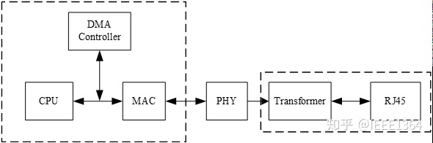
5、About the product
The number of applications requiring Ethernet connectivity continues to increase, driving Ethernet enabled devices into harsher environments.
The DP83848C/I/VYB/YB was designed to meet the challenge of these new applications with an extended temperature performance that goes beyond the typical Industrial temperature range. The DP83848C/I/VYB/YB is a highly reliable, feature rich, robust device which meets IEEE 802.3 standards over multiple temperature ranges from commercial to extreme temperatures. This device is ideally suited for harsh environments such as wireless remote base stations, automotive/transportation, and industrial control applications.
It offers enhanced ESD protection and the choice of an MII or RMII interface for maximum flexibility in MPU selection; all in a 48 pin package.
The DP83848VYB extends the leadership position of the PHYTER™ family of devices with a wide operating temperature range. The TI line of PHYTER transceivers builds on decades of Ethernet expertise to offer the high performance and flexibility that allows the end user an easy implementation tailored to meet these application needs.

